Phase III: Software Design and Modeling
1. Software Architecture
System Architecture
- Citizen registers an account
- Request goes to Backend
- Backend validates input (email uniqueness, password format)
- Backend encrypts password
- Data stored in the Users table
- Citizen account created successfully
- Citizen logs into the system
- Request goes to Backend
- Backend verifies email and password
- Backend checks encrypted password in Users table
- If valid, session is created
- Citizen is redirected to dashboard
- Citizen browses sports facilities
- Request goes to Backend
- Backend queries the Facilities table
- Backend returns list of facilities
- Citizen sees available facilities with details
- Citizen checks facility availability
- Request goes to Backend
- Backend queries:
  - facility_schedules table (working hours)
  - bookings table (existing reservations)
- Backend calculates available time slots
- Backend returns available slots
- Citizen sees real-time availability
- Citizen books a facility
- Request goes to Backend
- Backend validates citizen session and selected time slot
- Backend checks for conflicts in Bookings table
- If slot is free:
  - Booking is created
  - Stored in Bookings table
- Confirmation sent to citizen
- Citizen modifies a booking
- Request goes to Backend
- Backend verifies booking ownership
- Backend checks new time slot availability
- If valid:
  - Booking is updated in Bookings table
- Updated confirmation returned
- Citizen cancels a booking
- Request goes to Backend
- Backend verifies booking
- Booking status updated to cancelled in Bookings table
- Slot becomes available again
- System prevents double booking
- When booking request is received
- Backend checks existing records in Bookings table
- Unique constraint ensures no duplicate time slot per facility
- If conflict found
- Booking rejected
- Error returned to citizen
- Citizen receives booking notifications
- After booking action
- Backend triggers notification service
- Confirmation/reminder sent to citizen (email or system notification)
- Administrator adds or manages facilities
- Request goes to Backend
- Backend verifies admin role
- Backend inserts/updates/deletes data in Facilities table
- Changes saved
- Updated facilities visible to citizens
- Administrator manages citizens
- Request goes to Backend
- Backend checks admin privileges
- Backend updates citizen roles or data in Users table
- Changes applied successfully
- Administrator views reports and statistics
- Request goes to Backend
- Backend queries Bookings, Users, and Facilities tables
- Aggregated data returned
- Reports displayed
- Facility staff verifies bookings
- Request goes to Backend
- Backend validates staff role
- Backend updates booking status (verified) in Bookings table
- Booking marked as confirmed
- Facility staff views daily schedule
- Request goes to Backend
- Backend queries Bookings table filtered by date and facility
- Backend returns schedule
- Staff sees daily bookings
- Citizen makes payment
- Request goes to Backend
- Backend processes payment
- Payment details stored in Payments table
- Booking updated with payment status

Component Diagram (UML)
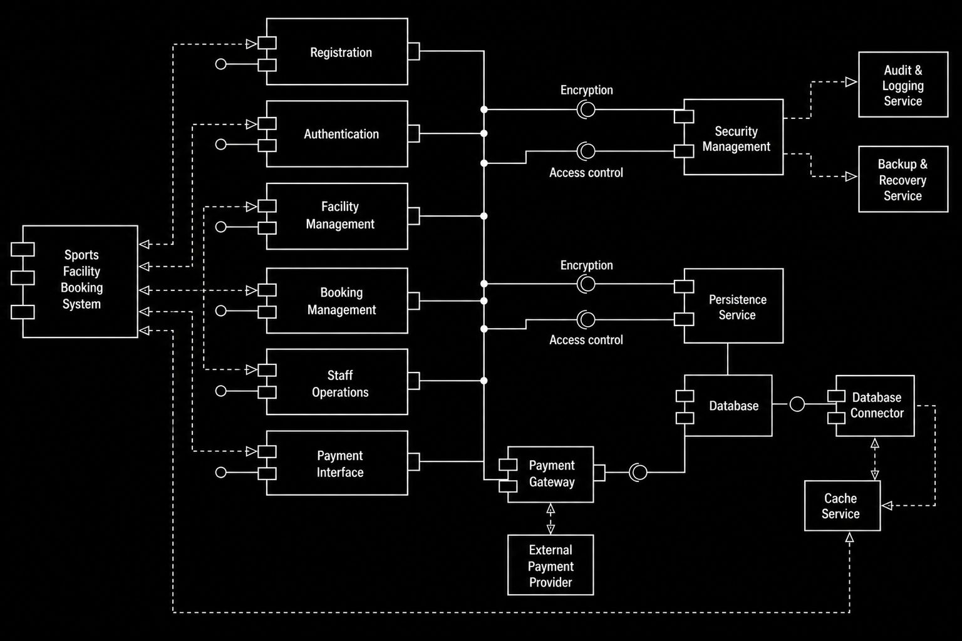
Components (Middle Part)
- Registration: handles new user sign-ups and account creation
- Authentication: manages login, identity verification, and user access
- Facility Management: manages sports facilities (courts, fields, availability, updates)
- Booking Management: handles reservations, schedules, and booking operations
- Staff Operations: manages staff roles, tasks, and internal operations
- Payment Interface: handles user payments and payment-related interactions
Left Side of the Diagram
- Sports Facility Booking System: represents the main system that connects all components together and serves as the central platform.
Data Access (Left Connections)
- All components are connected through a shared data flow
- Each module (Registration, Booking, Facility Management, etc.) can send and receive data
- This ensures consistent communication and proper data handling across the system
Right Side of the Diagram
- Security Management
- Ensures system protection through:
- Encryption: protects sensitive data (passwords, payment info)
- Access Control: ensures only authorized users can access certain features
- Additional services connected to security:
- Audit and Logging Service: records system activities for monitoring and tracking
- Backup and Recovery Service: ensures data safety and system recovery in case of failure
Persistence Service
- Handles storing and retrieving system data
- Acts as the bridge between application components and the database
- Also applies encryption and access control before storing data
Bottom Right Side
- Database: stores all system data (users, bookings, facilities, payments, staff info)
- Database Connector: manages communication between the persistence layer and the database
- Cache Service: temporarily stores frequently accessed data to improve performance and reduce database load
Bottom Middle (Payments)
- Payment Gateway: processes payment transactions
- External Payment Provider: third-party service (bank or payment API) that completes the transaction
Interaction Explanation
- System - Components: the main system communicates with all modules (registration, booking, etc.)
- Components - Security Management: all sensitive data passes through security (encryption and access control)
- Components - Persistence Service: data is sent for storage or retrieval
- Persistence - Database: data is stored in the database
- Database Connector: manages communication between persistence and the database
- Cache Service: speeds up data access by storing frequently used data
- Payment Flow:
Payment Interface → Payment Gateway → External Payment Provider

2. Detailed Design
Class Diagram
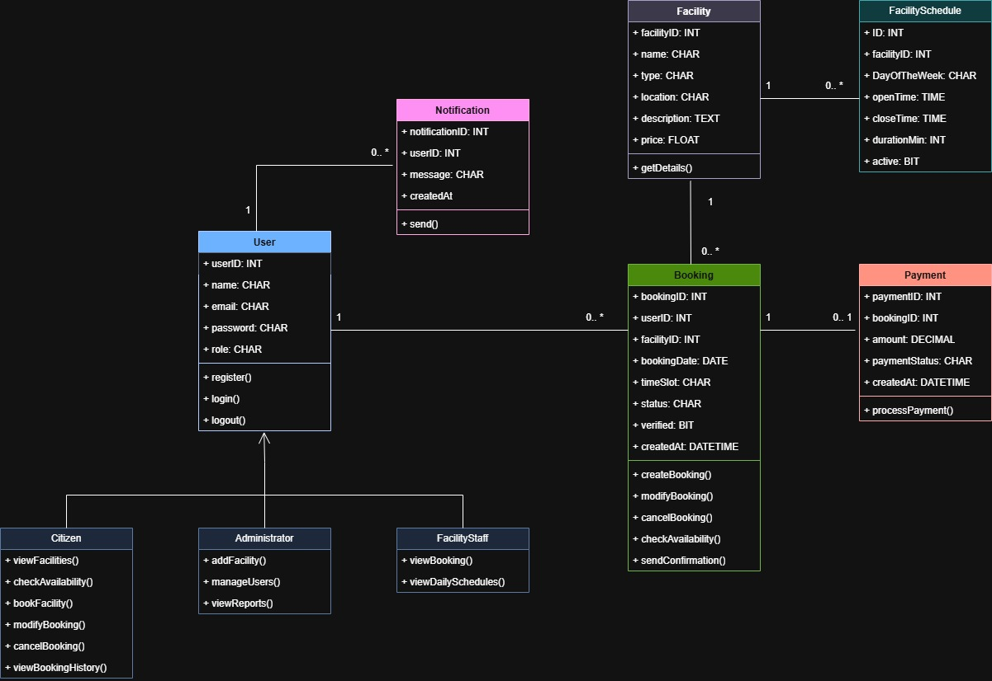

Sequence Diagrams
1. Facility Booking Sequence Diagram
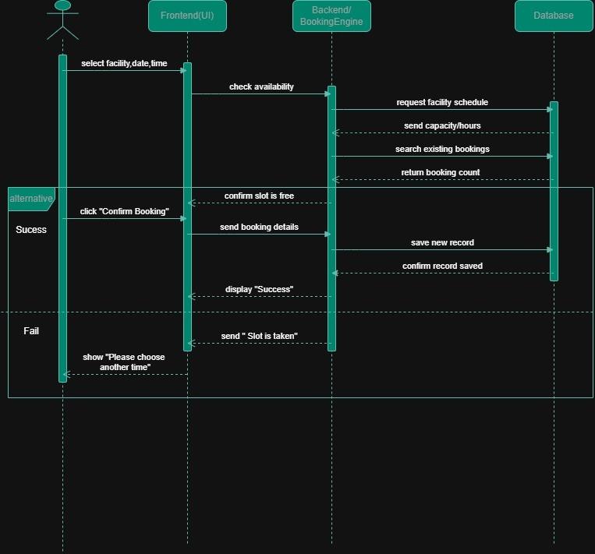
2. Admin: Add Facility Sequence Diagram
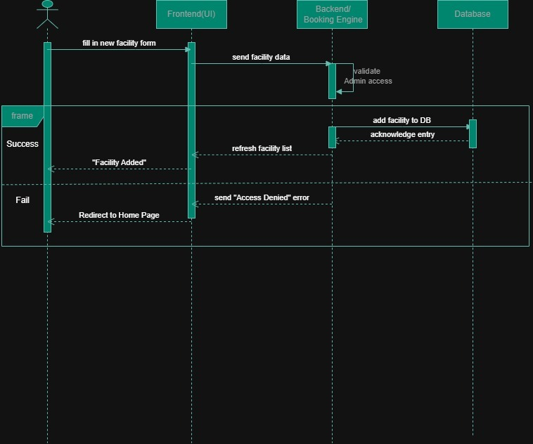
3. Optional Payment Sequence Diagram
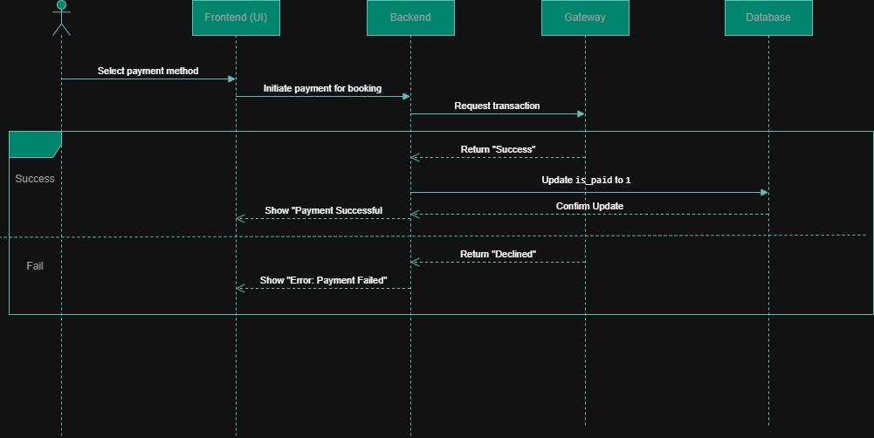

3. Modeling
Use Case Diagram
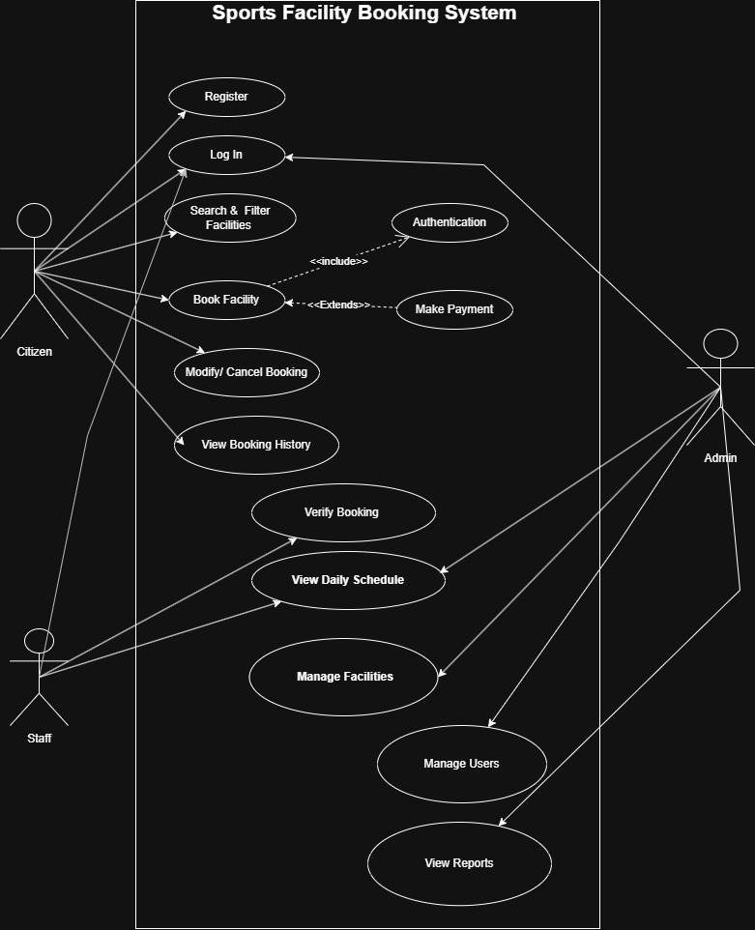

Activity Diagram
User Booking Process
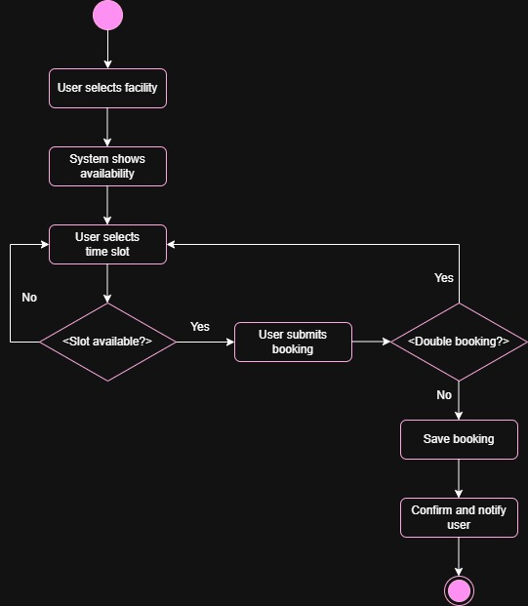

State diagram
- Payment Lifecycle
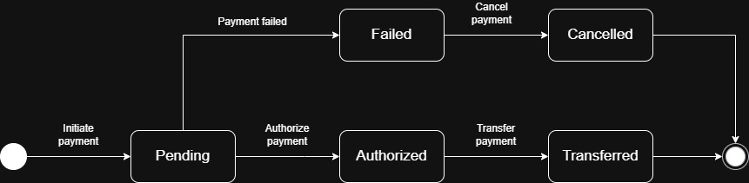
- Booking Lifecycle
